Name: **Rokeya Akanda Sriti**

ID:**1620165042**

Section:**02**

Report on Unnatural death in Bangladesh:

For my research on unnatural death in Bangladesh , the material I got **March 2017** reported by **Kaler Kontho**. By this paper there was so many news about murder, gunshot wound, suicide, act of terrorism ,road accident, natural disaster etc so on. I collected the data from newspaper and classified in the excel data sheet. I showed date , age , how he/she died, place, thana and also gave the link of the newspaper where the news is.

There were so many informative news in my given month. A total number of 138 people are fell victim to many unnatural death. There is also given the ages of victims . In the **Dhaka** city, the place where most amount of deaths occurred considering the huge amount of population in the capital.

Dhaka is the place where much occurrence of unnatural death happens too much. After Dhaka, Gazipur and Narayanganj came to the next. In These cases road accident and homicide occurred much and most of the people who died are maximumly **26-65year** old people. People died in their early ages due to road accidents.

In Bangladesh, People of age 26 to 65 died the most. It could be because this timeline is where a human is expected to be most active in his lifespan. Bangladesh needs major reconstruction of laws regarding driving of vehicles, footpaths, foot over-bridges etc. Unless strong implementation of law is reflected, these numbers would only grow. Another aspect is domestic violence. Many females were killed and made to look like suicide attempters by their in-laws.

Overseas research has shown that countries lose the most economically active people from road accident victims.it is argued that compared to the other costs of premature death in developing countries, deaths from road accidents appear to be increasing. The most vulnerable age group is 21 to 35 years representing the potential economic force group of Bangladesh. The situation is similar for drivers, passengers and pedestrians as well.

A large proportion of fatalities occur on rural sections of the main highways. Within urban areas, accident frequency is the highest on main road networks. There is evidence of 'clustering' of accidents at a few sites, indicating that the road safety problem may be partially addressed G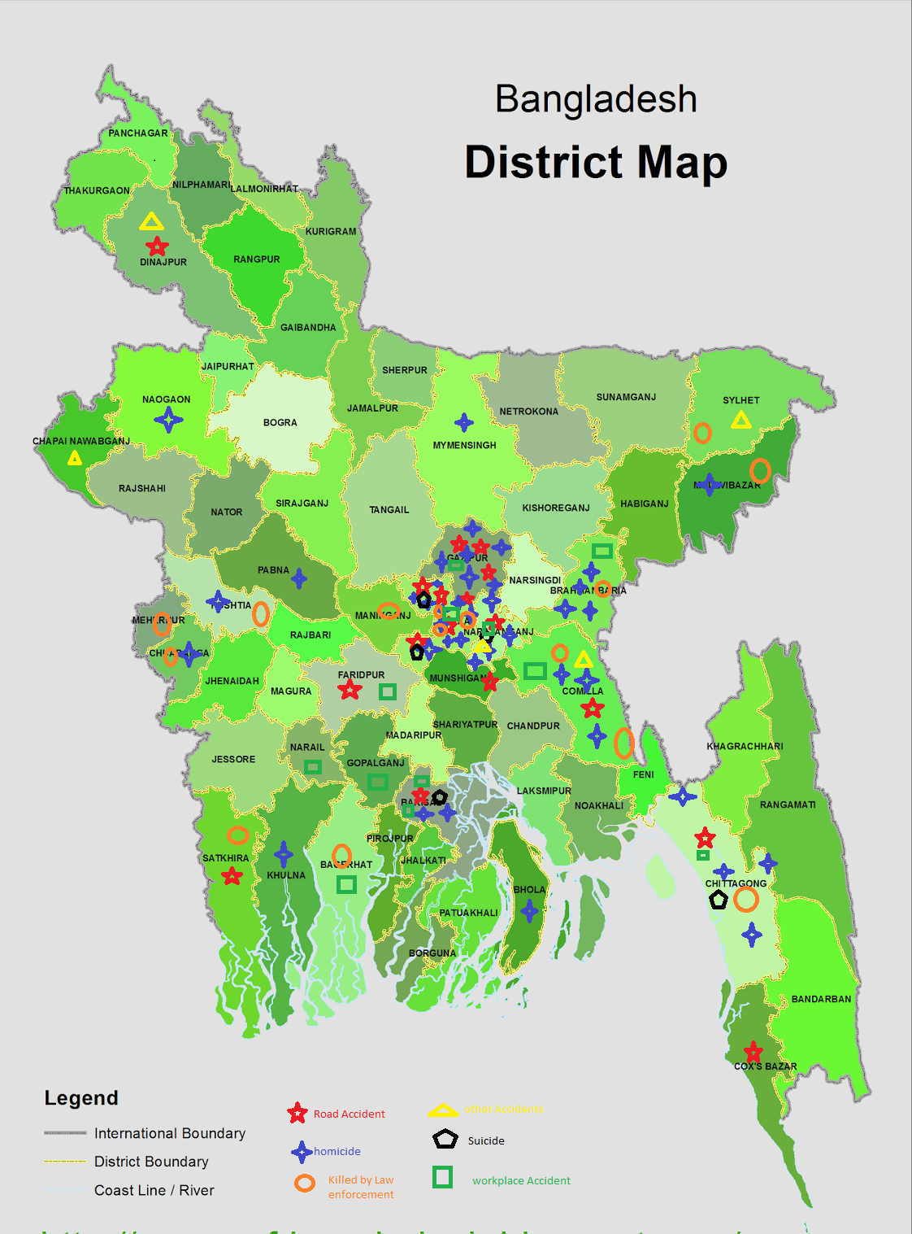by site-specific treatment. Frequent accident occurring road locations on highways and hazardous intersections under Dhaka City.

The other two issues that frequently occured were suicides committed for getting bad grades and various forms terrorist attacks. Bangladesh government should make more laws and also should maintain these laws to reduce the number of unnatural death.

People also died in some natural disaster. These unnatural deaths are very pathetic. People of all ages are victimized.

Overall, we need many major changes in our country, both lawfully and mentally to reduce the amount of unnatural deaths in our country.